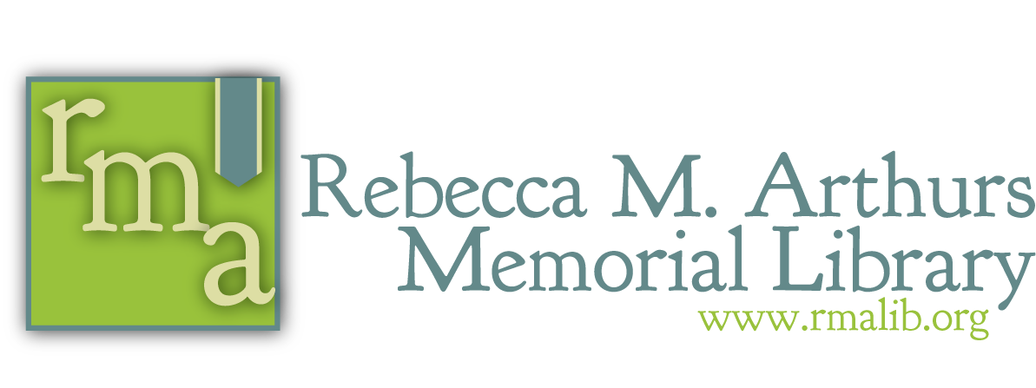

The Tech PLACE, The Research PLACE, The Story PLACE, The Work PLACE, The Meeting PLACE, The Study PLACE, The Movie PLACE.

September, 2018
Dear Library Friend,

In its 60th year of service, the Rebecca M. Arthurs Memorial Library remains a safe and vital PLACE for education and information access. Because I know you value the library and the services it provides to our community, please consider a year-end gift to the Rebecca M. Arthurs Memorial Library.

Libraries today are less about what they have for people and more about what they do for and with people. They are a PLACE providing assistance, knowledge, entertainment, and a sense of community. Your generous past gifts have provided the library with the funds needed to implement its mission, with programs, events, and materials such as:

- Tiny Tots, Hands-On Story Time, and STEM Saturday
- Young Writers, and Teen Reading Club
- Rebecca’s Readers Book Club
- Poetry and Short Story Contests, and adult and young adult author presentations
- Thousands of books, audiobooks, DVDs and e-resources
- Free use of computers and the Internet

Our library is working to provide these services on a budget that reflects ever decreasing state and local assistance. This year, the library’s goal is to raise $22,000. We have currently reached only 47% of that goal. The library exists to serve our patrons and our community, but we can’t do it alone. With your donation, we can achieve our mission, and make the library the PLACE for you, your family and your community.

Thank you for your generosity and your support.

Sincerely,
Ruth Rowan Janine Strohm
Board President Director

Your donation can be made online through PayPal (accessible from our webpage www.rmalib.org/supportthelibrary), by mail, or in person. Checks should be made out to Rebecca M Arthurs Memorial Library.
All gifts are tax-deductible to the fullest extent of the law.

For questions contact us at:
Email: rmalibdirector@gmail.com Call: 814-849-5512
Rebecca M. Arthurs Memorial Library Non-Profit Organization
223 Valley St. US Postage Paid
Brookville, PA 15825 Falls Creek, PA 15840
Return Service Requested Permit No. 130

